***COURSEWORK: ETHEREUM ANALYSIS***

*PART A. TIME ANALYSIS (20%)*

*Create a bar plot showing the number of transactions occurring every month between the start and end of the dataset.*

*Create a bar plot showing the average value of transaction in each month between the start and end of the dataset.*

*Note: As the dataset spans multiple years and you are aggregating together all transactions in the same month, make sure to include the year in your analysis.*

*Note: Once the raw results have been processed within Hadoop/Spark you may create your bar plot in any software of your choice (excel, python, R, etc.)*

DATASET SCHEMA – TRANSACTIONS

|  |  |
| --- | --- |
| block_number | Block number where this transaction was in |
| from_address | Address of the sender |
| to_address | Address of the receiver. null when it is a contract creation transaction |
| value | Value transferred in Wei (the smallest denomination of ether) |
| gas | Gas provided by the sender |
| gas_price | Gas price provided by the sender in Wei |
| block_timestamp | Timestamp the associated block was registered at (effectively timestamp of the transaction) |

* To calculate number of transactions occurring every month the **block_timestamp** field is used.
* The aggregate **sum(values)** of all the timestamp values per month returns the total number of transactions occurred.

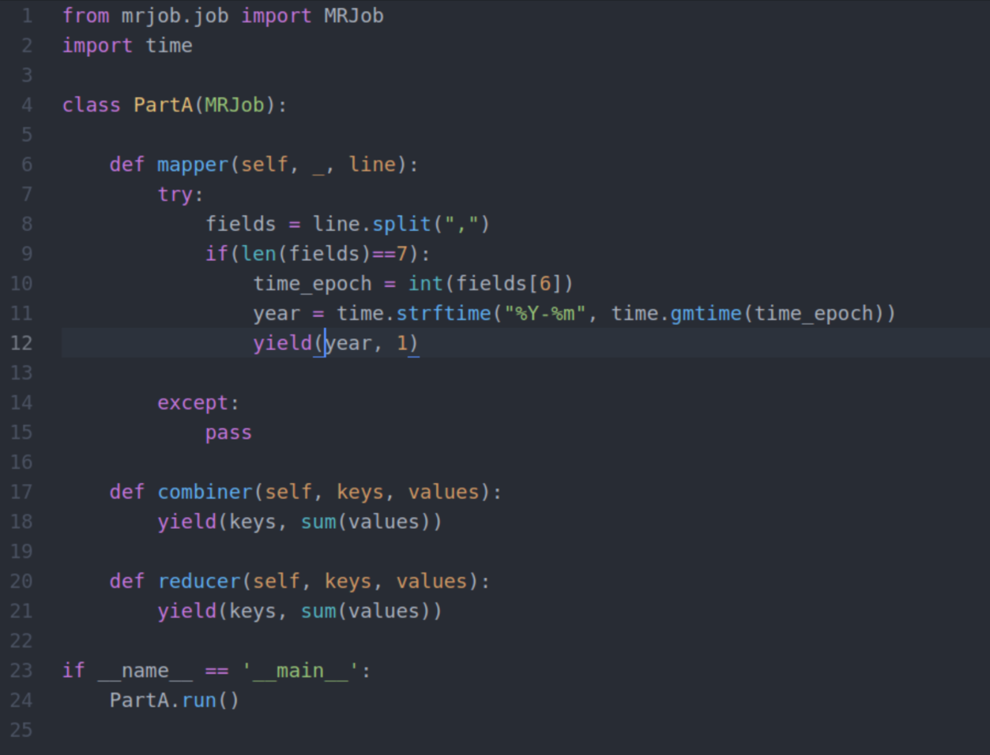

Figure 1: PartA.py

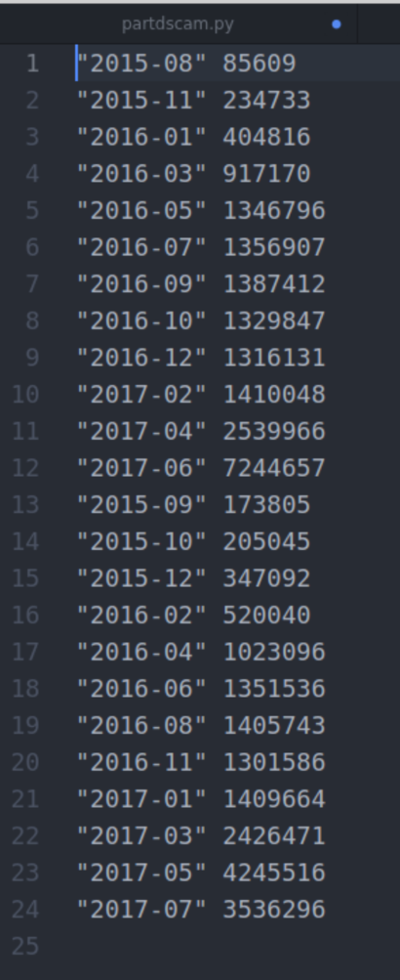Code Explanation:

* Libraries imported are MRJob and time.
* Map/Reduce job to calculate initial aggregation reads the lines in the **transactionSmall** file with delimiter comma.
* The if statement checks if the **len(fields)** is exactly equal to the number of columns in the dataset **(7).**
* The block_timestamp field is defined as **int** to process the timestamp values. The **time.gmtime** is used to convert the Unix timestamp values to Gregorian format MM-YY.
* The mapper yields the formatted timestamp values.
* **sum(values)** in the **combiner** performs the aggregation on timestamp value which returns the total count of transaction in the mapper.
* **sum(values)** in the **reducer** calculates the aggregate of the transaction values.
* The final output yields the total count of transaction per month.

Command Line:

>>python PartA.py -r hadoop –output-dir PartAout –no-cat-output hdfs://andromeda.eecs.qmul.ac.uk/data/ethereum/transactionSmall

Figure 2: PartAout

Figure 3: PartA_out

Job Id:

<http://andromeda.student.eecs.qmul.ac.uk:8088/proxy/application_1606730688641_7787/>

Graph:

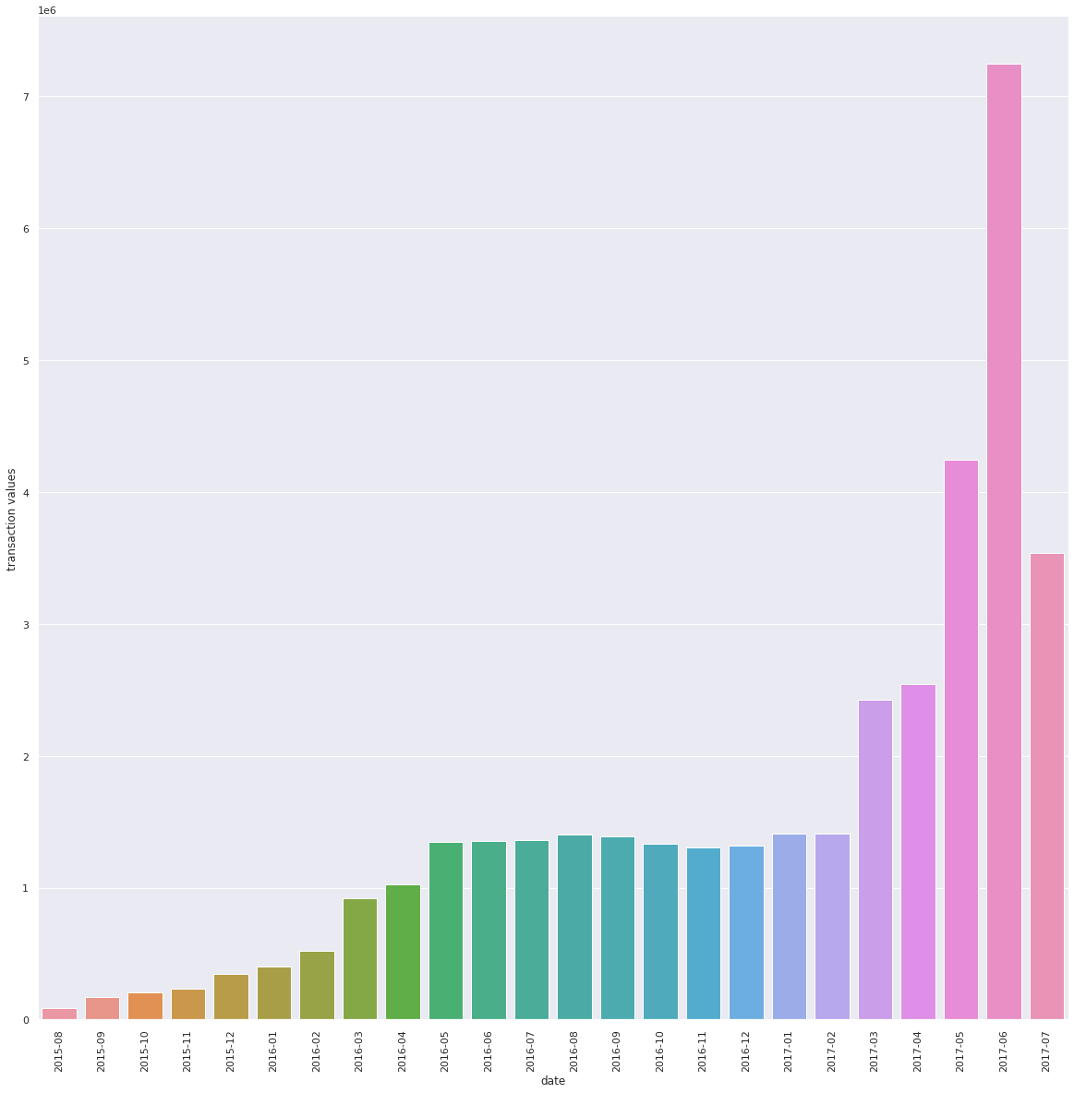

Graph 1: Number of Transaction occurring every month

* To calculate the average value of transactions each month we use **value** fields.

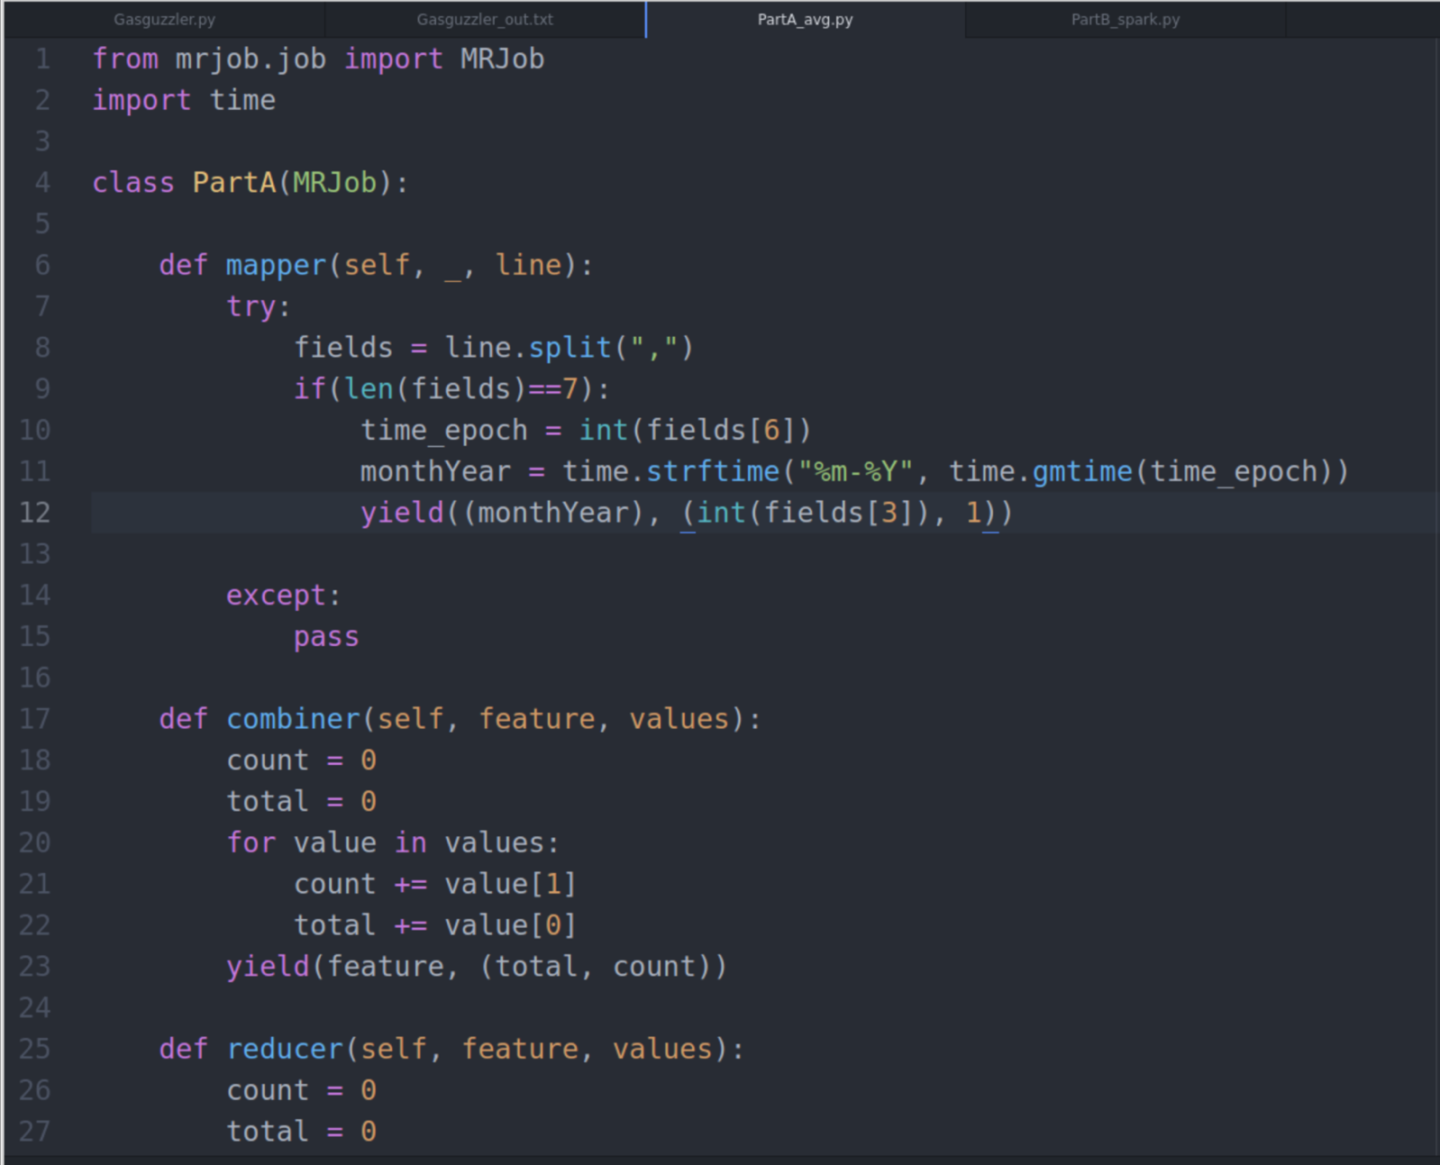

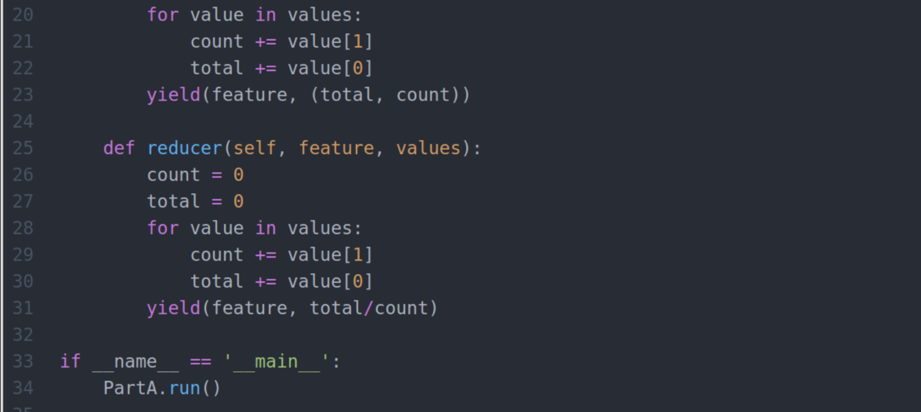

Figure 3: PartA_avg.py

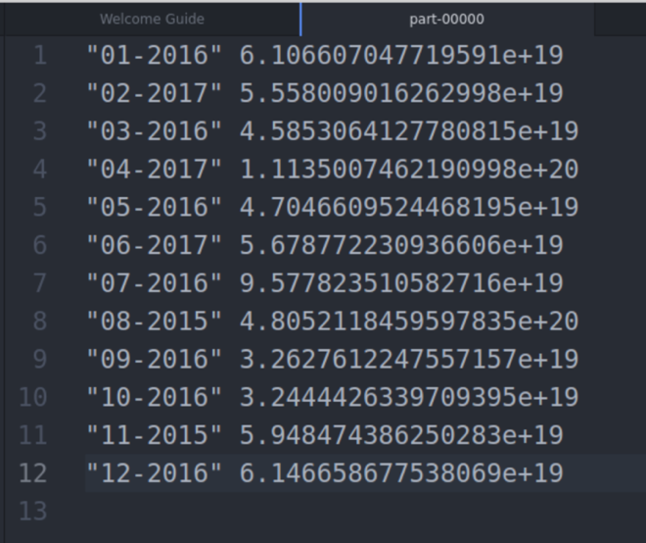Code Explanation:

* A Map/Reduce job is used to perform this computation. In mapper, **key** is **month-year** in Gregorian format and values are **value** and **count 1** to count the number of occurrences which is used later in reducer to calculate the average.
* In combiner, the key is the formatted timestamp and values are value and count. A for loop is used to calculate the sum of values and its number of occurrences per month.
* In reducer, the total/count yields average values per month. The average is calculated by dividing the sum of values with its total number of occurrences.
* Finally, the result is the average value of transaction per month.

Figure 4: PartA_avg_out

Command Line:

>>python PartA_avg.py -r hadoop –output-dir PartA_avg_out –no-cat-output hdfs://andromeda.eecs.qmul.ac.uk/data/ethereum/transactionSmall

Job Id:

<http://andromeda.student.eecs.qmul.ac.uk:8088/proxy/application_1606730688641_5889/>

Graph:

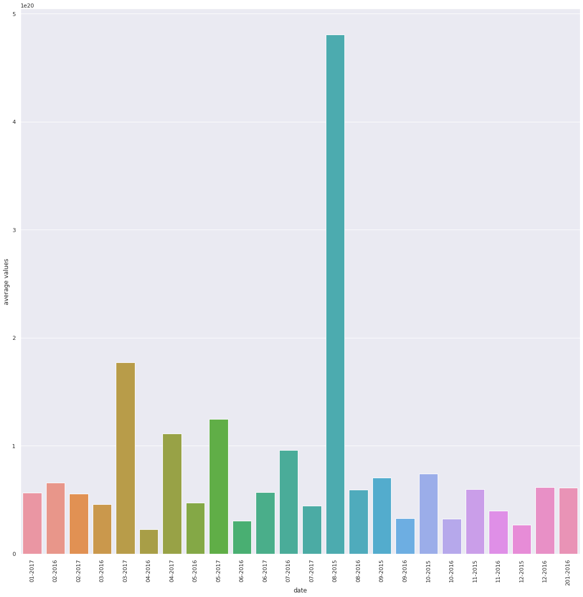

Graph 2: Average Value of transaction each month

***PART B. TOP TEN MOST POPULAR SERVICES (20%)***

## *Evaluate the top 10 smart contracts by total Ether received. An outline of the subtasks required to extract this information is provided below, focusing on a MRJob based approach. This is, however, only one possibility, with several other viable ways of completing this assignment.*

## DATASET SCHEMA - CONTRACTS

|  |  |
| --- | --- |
| **address** | Address of the contract |
| **is_erc20** | Whether this contract is an ERC20 contract |
| **is_erc721** | Whether this contract is an ERC721 contract |
| **block_number** | Block number where this contract was created |

### *JOB 1 - INITIAL AGGREGATION*

### *To workout which services are the most popular, you will first have to aggregate****transactions****to see how much each address within the user space has been involved in. You will want to aggregate****value****for addresses in the****to_address****field. This will be similar to the wordcount that we saw in Lab 1 and Lab 2.*

Figure 5: PartB_1.py

Code Explanation:

* Map/Reduce job is used to calculate the initial aggregation with key as **to_address** and value as **values** from transaction file.
* In mapper, the lines are split by comma and the key and values are yielded only if the **values** field is not zero. This will remove all the lines that are not required for computation, thus saving memory and improving the execution performance of the job.
* A combiner is used to calculate the sum of values for each transaction present in each mapper.
* Adding a combiner improves the aggregation performance of the job.
* Finally, in the reducer the same sum operation is used to calculate the aggregate of transaction values.
* The output is the sum of values in Wei for each transaction. This tells us how much each address within the user space has been involved in.

Command Line:

>>python PartB_1.py -r hadoop –output-dir PartB_1out –no-cat-output hdfs://andromeda.eecs.qmul.ac.uk/data/ethereum/transactionSmall

Job Id:

<http://andromeda.student.eecs.qmul.ac.uk:8088/proxy/application_1607539937312_1075/>

Output Snippet:

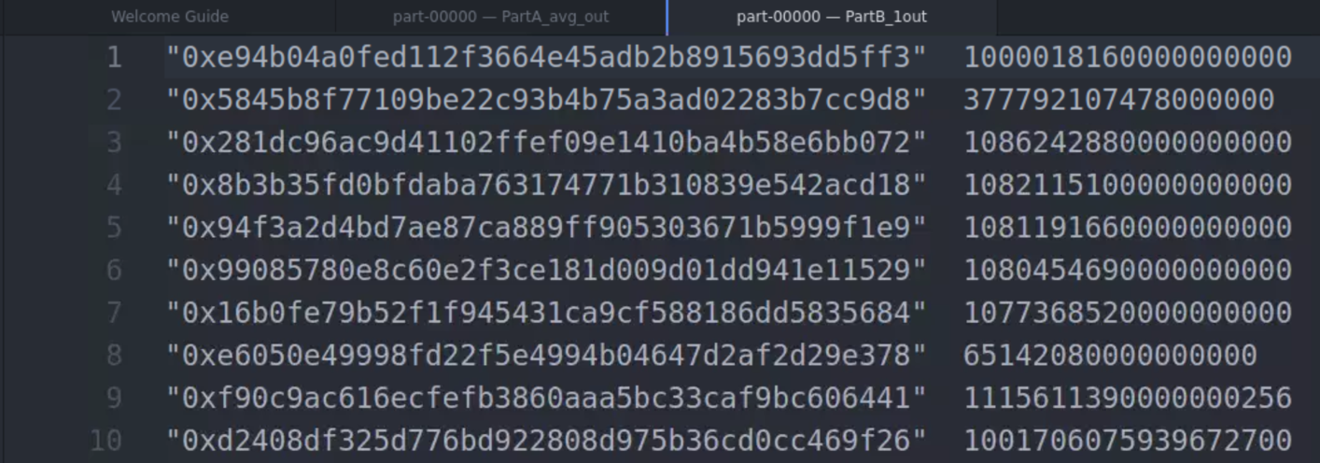

Figure 6: PartB_1out

### *JOB 2 - JOINING TRANSACTIONS/CONTRACTS AND FILTERING*

*Once you have obtained this aggregate of the transactions, the next step is to perform a repartition join between this aggregate and****contracts****(example*[*here*](https://qmplus.qmul.ac.uk/mod/page/view.php?id=1404848)*). You will want to join the****to_address****field from the output of Job 1 with the****address****field of****contracts***

*Secondly, in the reducer, if the address for a given aggregate from Job 1 was not present within****contracts****this should be filtered out as it is a user address and not a smart contract.*

* We perform repartition join between **contracts** dataset and t**ransactionSmall** dataset (JOB 1 output) to filter out user address from smart contract address. The output will only list address that belongs to smart contracts.

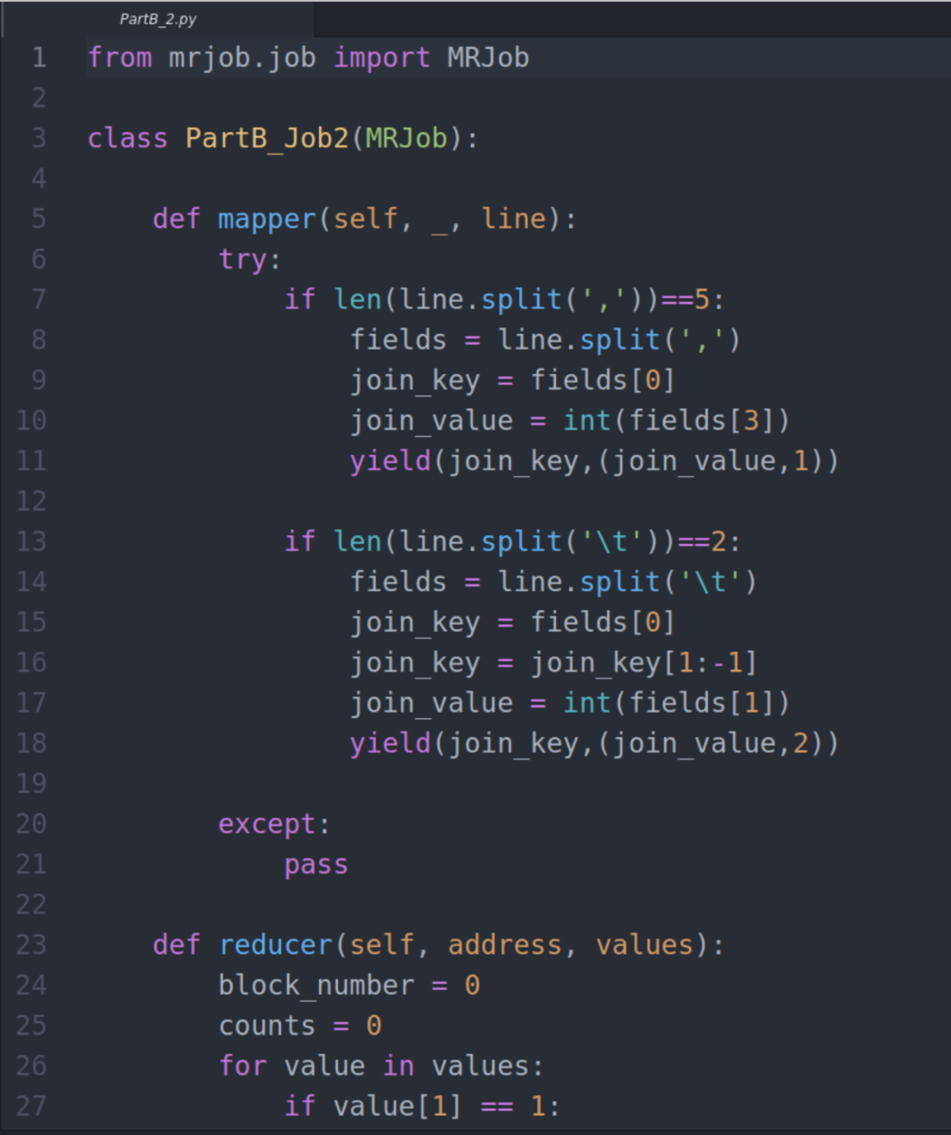

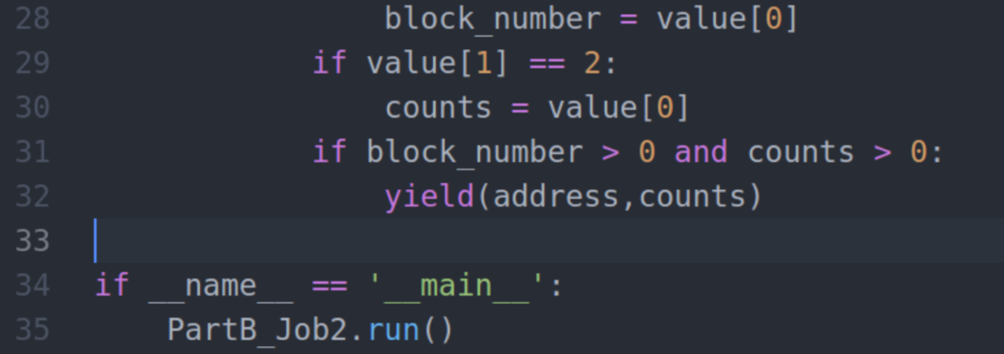

Figure 7: PartB_2.py

Code Explanation:

* Map/Reduce job to perform repartition join between contracts dataset and transaction aggregate dataset (PartB_1_out.txt).
* In the mapper we are differentiating the two input files by checking the number of fields present in the file. If the number of fields is 5 its contracts dataset and of number of fields is 2 its transactions aggregate dataset (output from JOB 1).
* The first if condition in mapper recognises the contracts dataset where we specify **key as address**(fields[0]) and **value as block_number and ‘1’.** 1 is hardcoded to identify that the value is from contracts dataset at the reducer.
* The second if condition in mapper recognises the transactions aggregate dataset where we specify **key as address** and **value as aggregate count (sum of values in Wei).**
* The mapper takes records only if both the keys matches. That is only if address from both the dataset matches. By this way we filter smart contract address.
* In the reducer using for loop I identified the **aggregate values** count from the set of values yielded by mapper. If value[1] == 2 then **counts** is the **aggregate value.**
* Finally, the **key** which is the **smart contract address** and **value** which is the **aggregate value** is yielded in the reducer which gives us the aggregate values of all smart contracts.

Command Line:

>>python PartB_2.py -r hadoop –output-dir PartB_2_out –no-cat-output hdfs://andromeda.eecs.qmul.ac.uk/data/ethereum/contracts PartB_1_out.txt

Job Id:

<http://andromeda.student.eecs.qmul.ac.uk:8088/proxy/application_1607539937312_1084/>

Output Snippet:

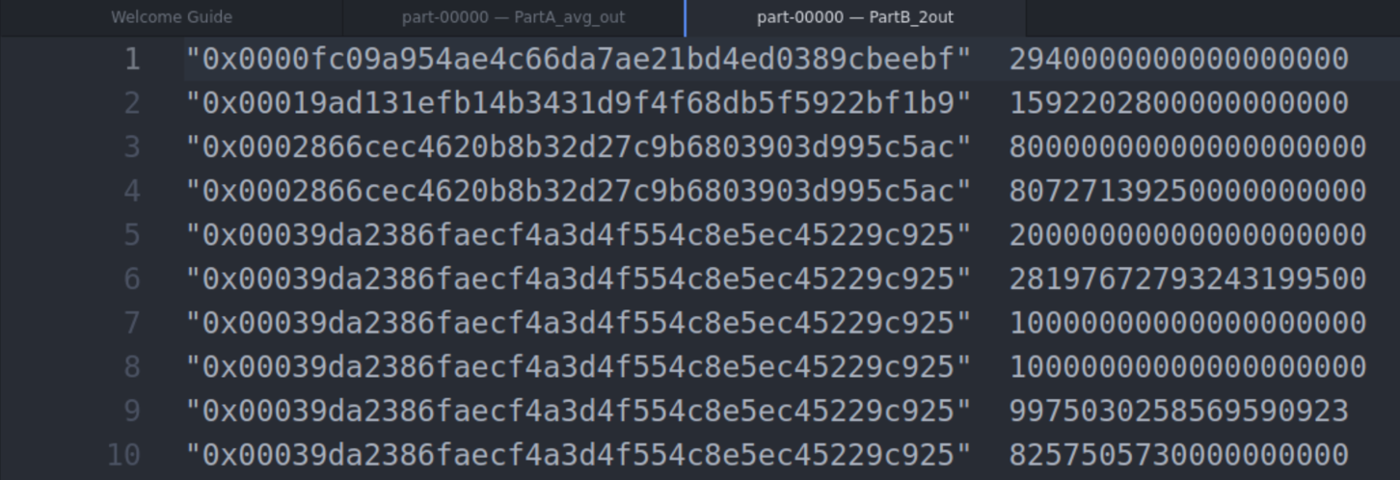

Figure 8: PartB_2out

### *JOB 3 - TOP TEN*

*Finally, the third job will take as input the now filtered address aggregates and sort these via a top ten reducer, utilising what you have learned from lab 4.*

* The output from the previous JOB 2 will be taken as input in JOB3.
* The values will be sorted based on total aggregate value to obtain the top 10 contracts.

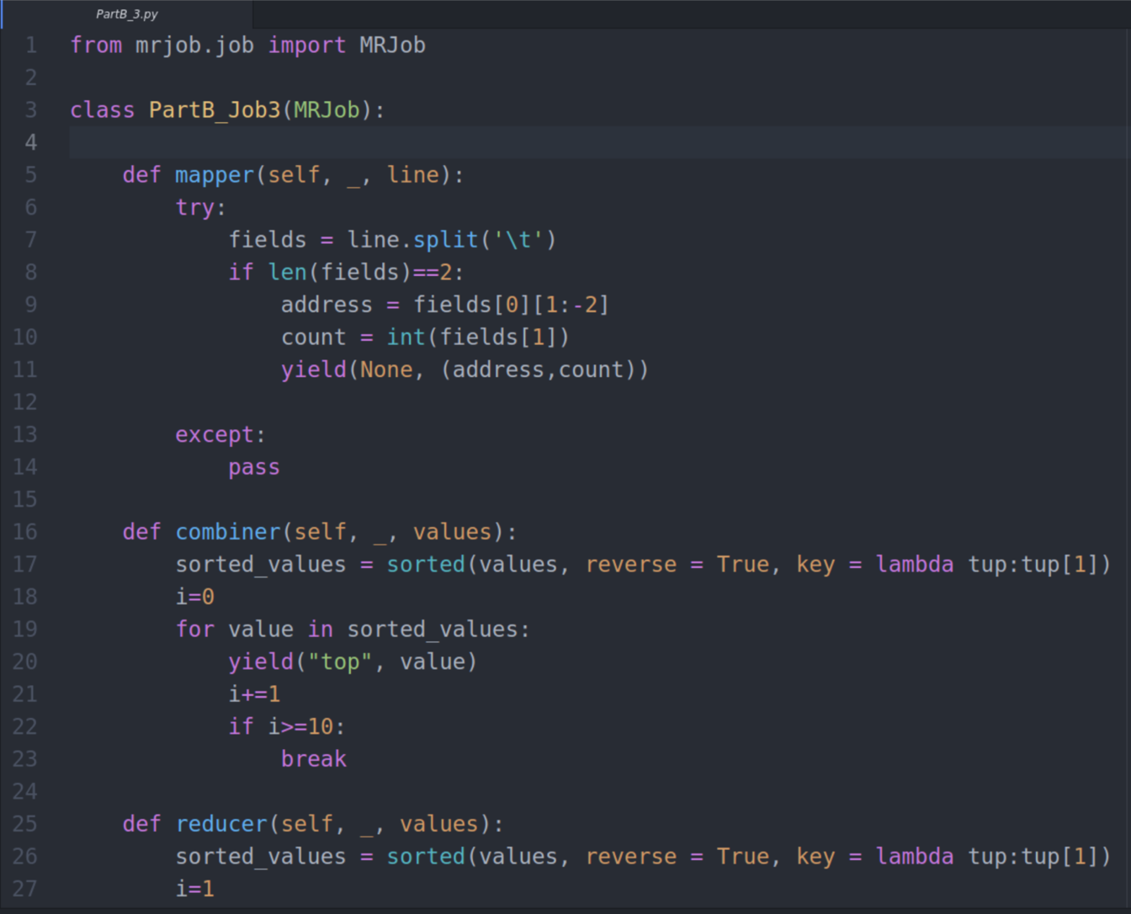

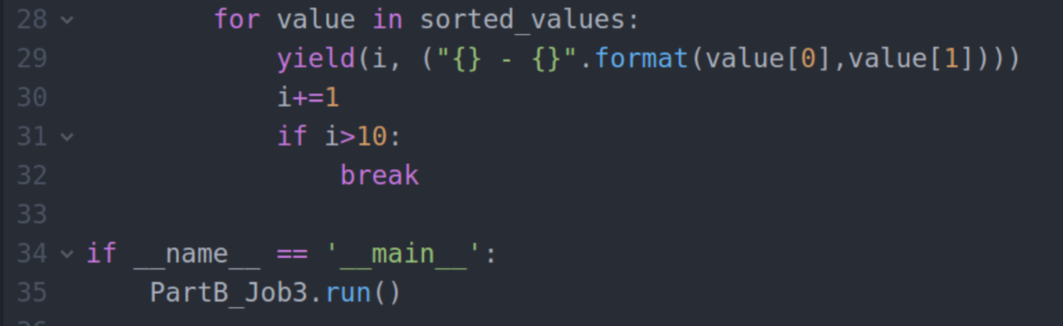

Figure 9: PartB_3.py

Code Explanation:

* Map/Reduce job is to filter out top 10 most popular services obtained as a result from Job 2 output.
* In the mapper, the lines are split by tab since the input file is tab separated. **Key is None** and value is the **address and sum of aggregate values.** Key is none because we need to sort the values based on the aggregate count.
* A combiner is used to speed up the sorting process. In combiner sort the values in ascending order by giving **reverse = True.** This will return the top values first. After this condition has been set, a for loop is used to iterate between all the records and yield the sorted values in ascending order.
* Finally, in reducer the same combiner operation is performed where key value pairs from all the combiners are sorted once again to obtain the exact result. A for loop is used to iterate between all the records from combiner and the result is displayed in the top 10 order. In order to display only top 10 values, the for loop is terminated if the iteration count reaches 11.
* Output is the top 10 most popular services.

Job Execution:

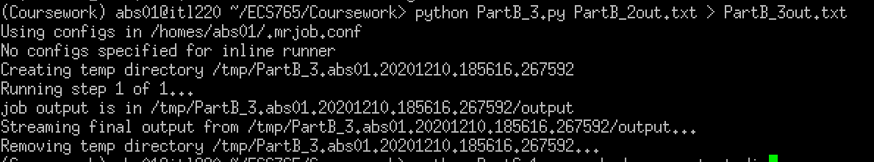

Figure 10: PartB_3run

Output:

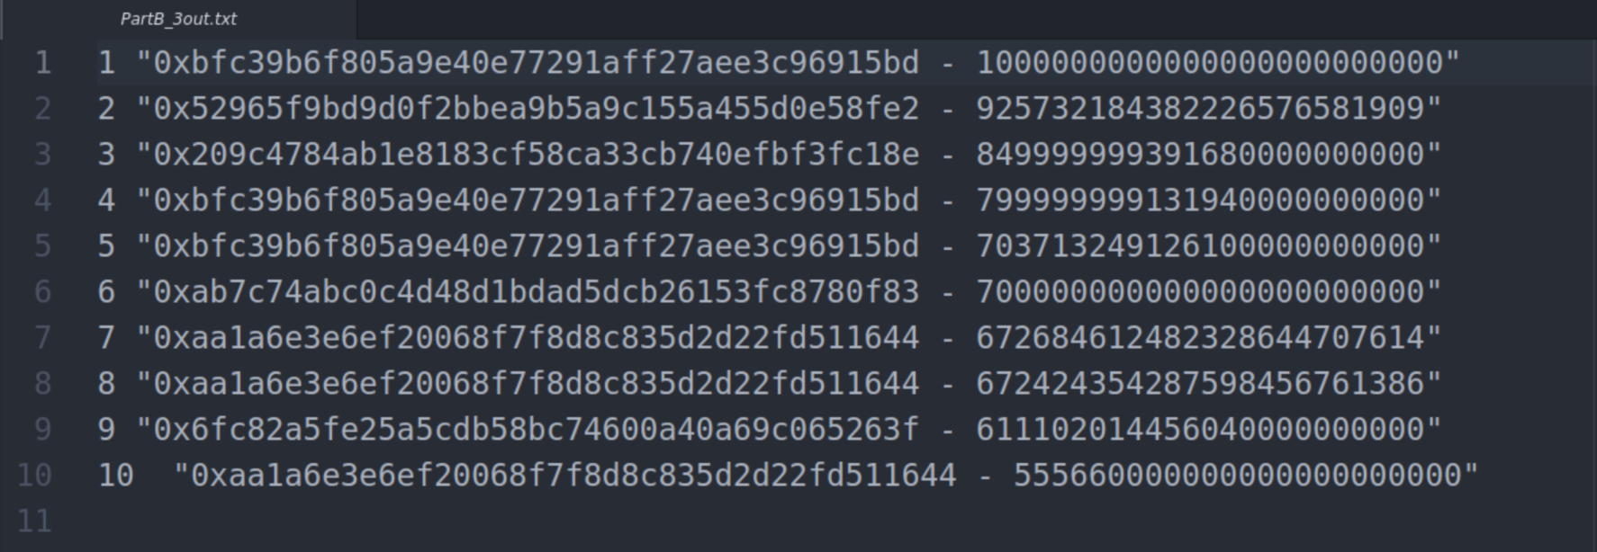

Figure 11: PartB_3out

*PART C. TOP TEN MOST ACTIVE MINERS (10%)*

*Evaluate the top 10 miners by the size of the blocks mined. This is simpler as it does not require a join. You will first have to aggregate blocks to see how much each miner has been involved in. You will want to aggregate size for addresses in the miner field. This will be similar to the wordcount that we saw in Lab 1 and Lab 2. You can add each value from the reducer to a list and then sort the list to obtain the most active miners.*

DATASET SCHEMA – BLOCKS

|  |  |
| --- | --- |
| **number** | The block number |
| **hash** | Hash of the block |
| **miner** | The address of the beneficiary to whom the mining rewards were given |
| **difficulty** | Integer of the difficulty for this block |
| **size** | The size of this block in bytes |
| **gas_limit** | The maximum gas allowed in this block |
| **gas_used** | The total used gas by all transactions in this block |
| **timestamp** | The timestamp for when the block was collated |
| **transaction_count** | The number of transactions in the block |

* We perform initial aggregation on **blocks** dataset.

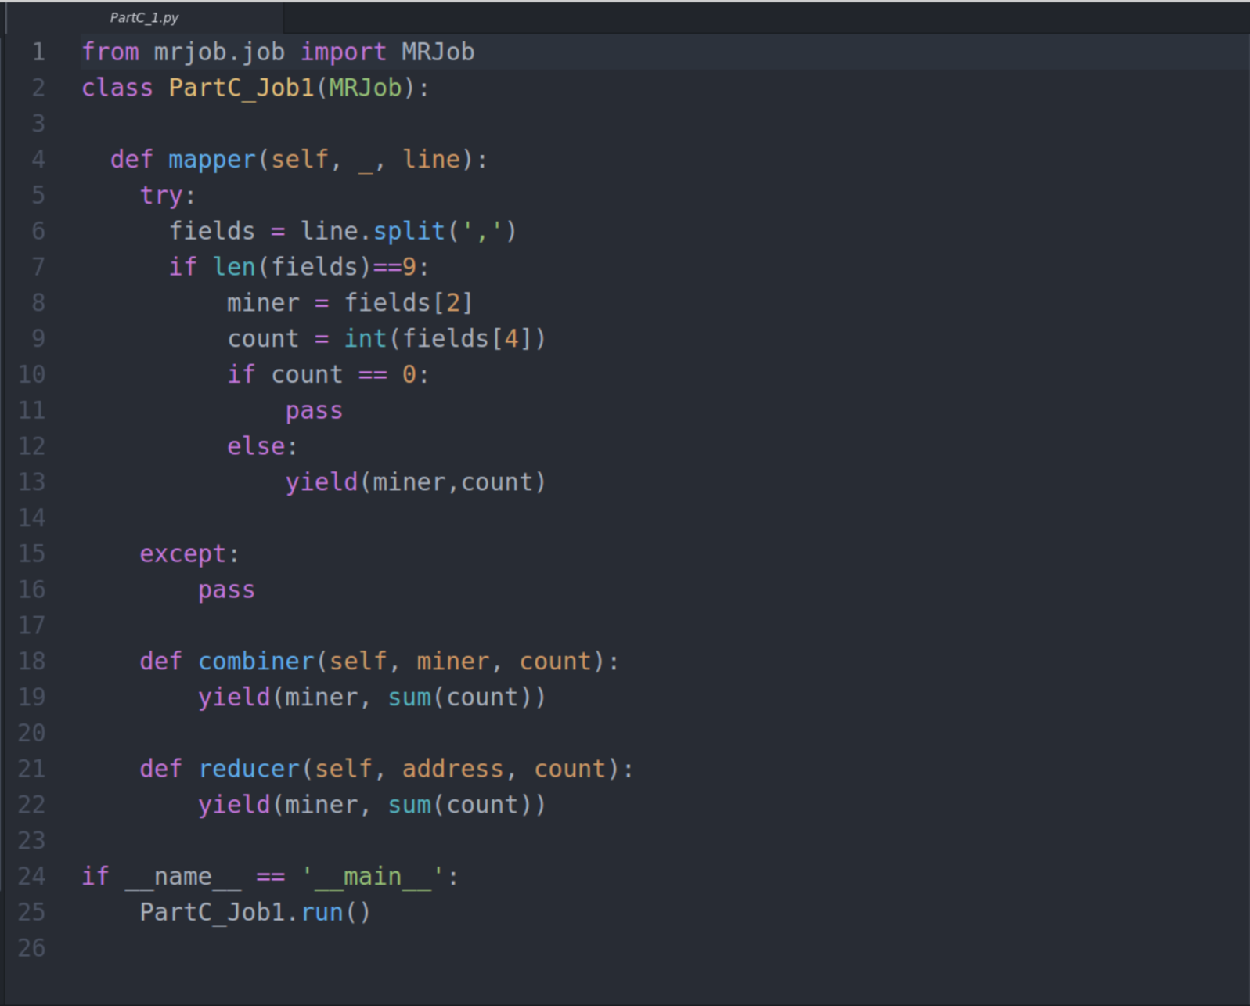

Figure 12: PartC_1.py

Code Explanation:

* Map/Reduce job is used to calculate the initial aggregation with key as **miner** and value as **size**.
* In mapper, the lines are split by comma and the key and values are yielded only if the **values** field is not zero. This will remove all the lines that are not required for computation, thus saving memory and improving the execution performance of the job.
* A combiner is used to calculate the sum of values for each block mined present in each mapper.
* Adding a combiner improves the aggregation performance of the job.
* Finally, in the reducer the same sum operation is used to calculate the aggregate of blocks.
* The output is the sum of values of blocks mined. This tells us how much each miner has been involved in.

Command Line:

>>python PartC_1.py -r hadoop –output-dir PartC_1out –no-cat-output hdfs://andromeda.eecs.qmul.ac.uk/data/ethereum/blocks

Job Id:

<http://andromeda.student.eecs.qmul.ac.uk:8088/proxy/application_1607539937312_1105/>

Output Snippet:

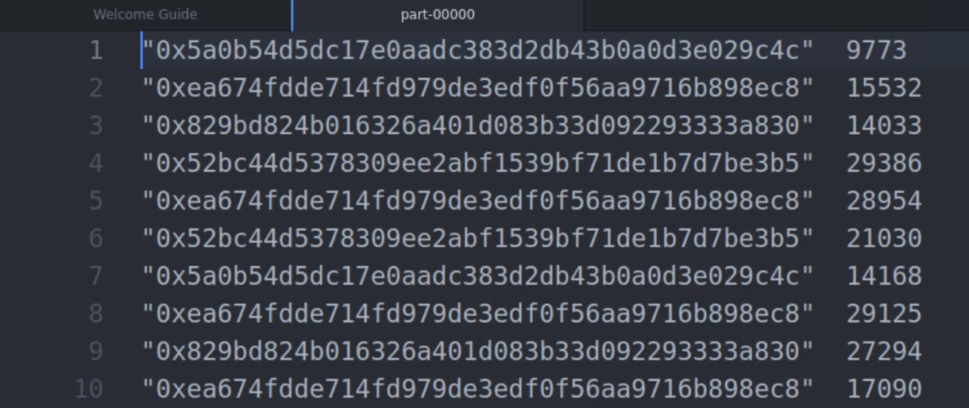

Figure 13: PartC_1out

* The output of the **PartC_1** is used as an input to obtain the top 10 miners.

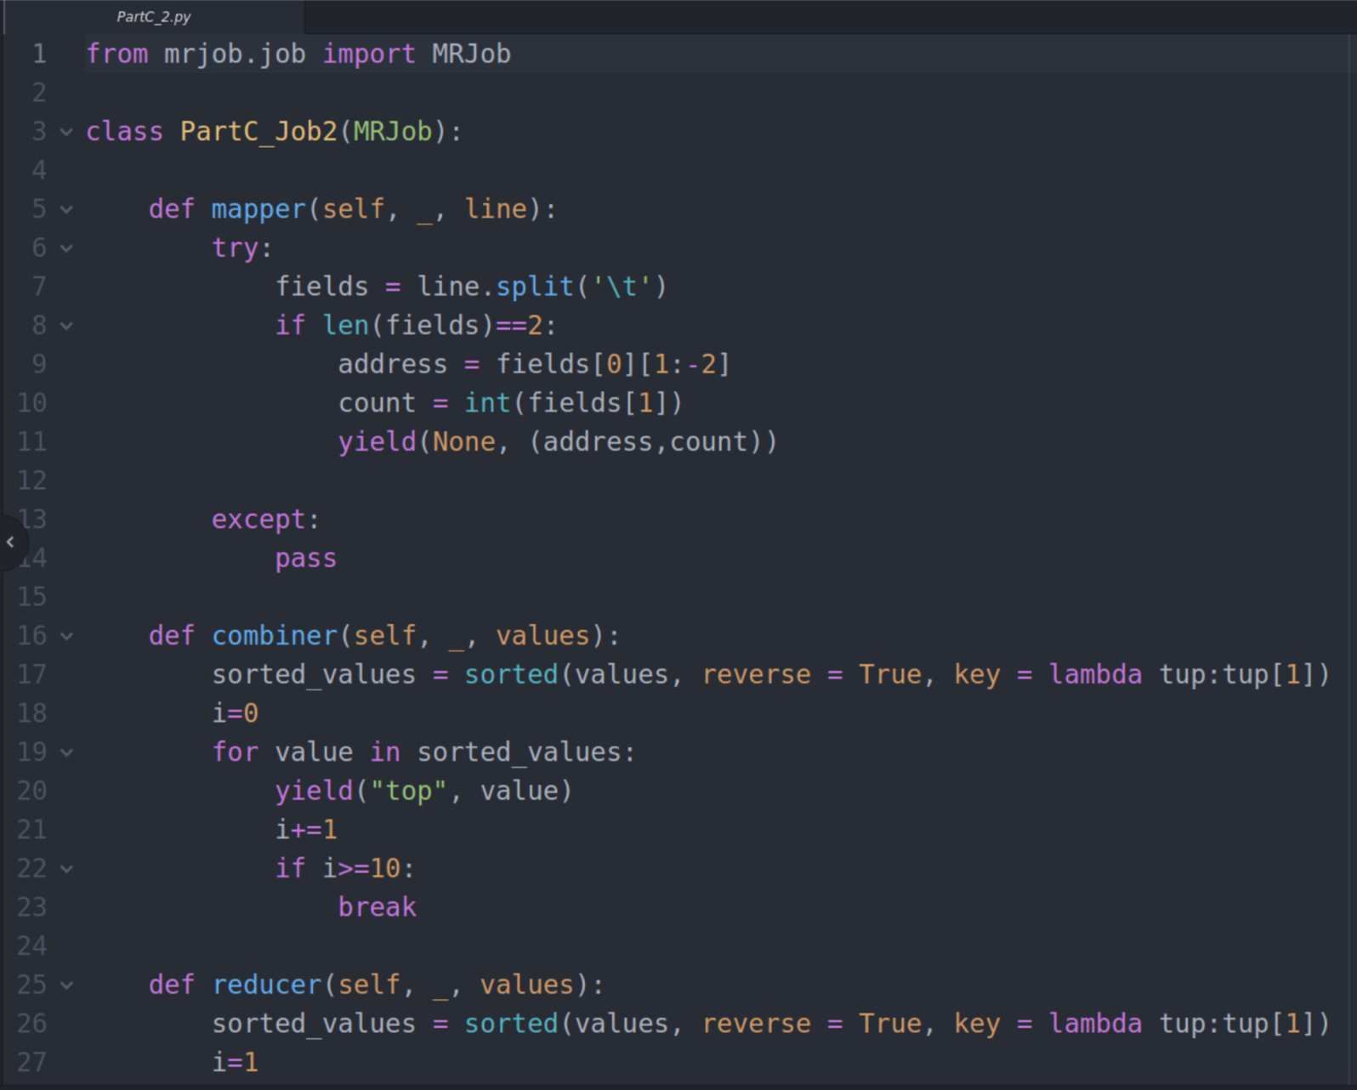

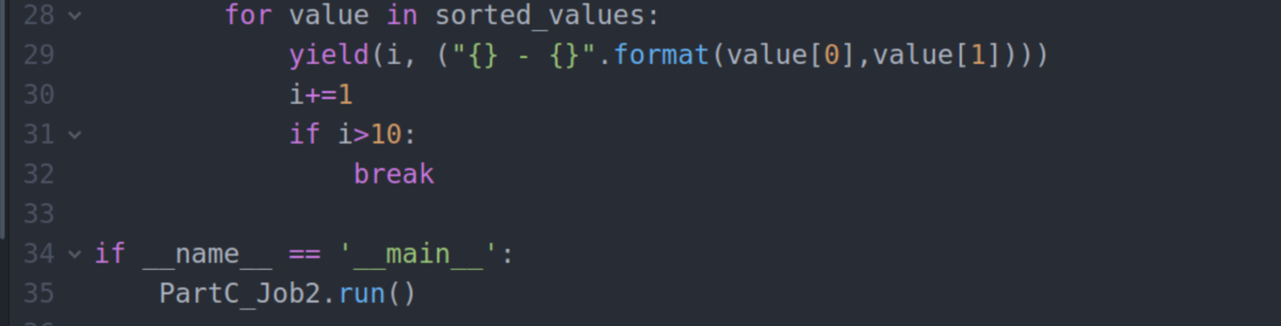

Figure 14: PartC_2.py

Code Explanation:

* Map/Reduce job is to filter out top 10 miners obtained as a result from Job 1 output. (PartC_1out.txt)
* In the mapper, the lines are split by tab since the input file is tab separated. **Key is None** and value is the **address and sum of aggregate values.** Key is none because we need to sort the values based on the aggregate count.
* A combiner is used to speed up the sorting process. In combiner sort the values in ascending order by giving **reverse = True.** This will return the top values first. After this condition has been set, a for loop is used to iterate between all the records and yield the sorted values in ascending order.
* Finally, in reducer the same combiner operation is performed where key value pairs from all the combiners are sorted once again to obtain the exact result. A for loop is used to iterate between all the records from combiner and the result is displayed in the top 10 order. In order to display only top 10 values, the for loop is terminated if the iteration count reaches 11.
* Output is the top 10 miners.

Job Execution:

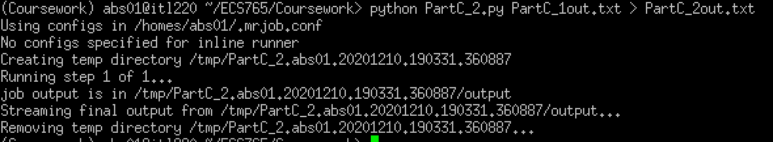

Figure 15: PartC_2run

Output:

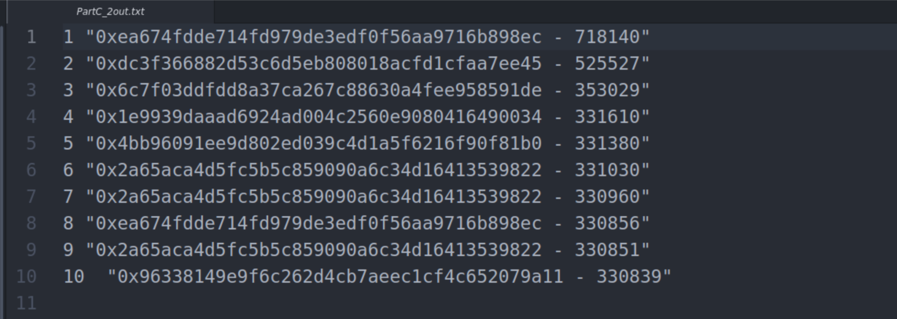

Figure 16: PartC_2out

*PART D. DATA EXPLORATION (50%)*

*The final part of the coursework requires you to explore the data and perform some analysis of your choosing. These tasks may be completed in either MRJob or Spark, and you may make use of Spark libraries such as MLlib (for machine learning) and GraphX for graph analysis. Below are some suggested ideas for analysis which could be undertaken, along with an expected grade for completing it to a goodstandard. You may attempt several of these tasks or undertake your own. However, it is recommended to discuss ideas with Joseph before commencing with them.*

*SCAM ANALYSIS*

*Popular Scams: Utilising the provided scam dataset, what is the most lucrative form of scam? How does this change throughout time, and does this correlate with certain known scams going offline/inactive? (15/50)*

Most lucrative Scam Analysis:

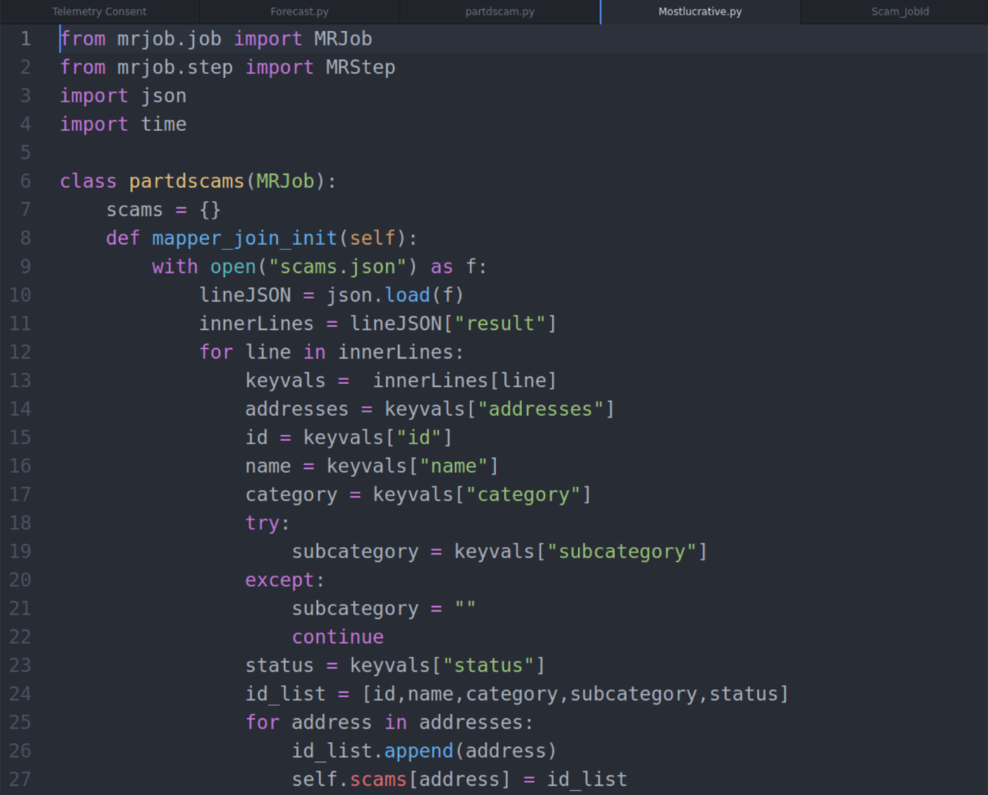

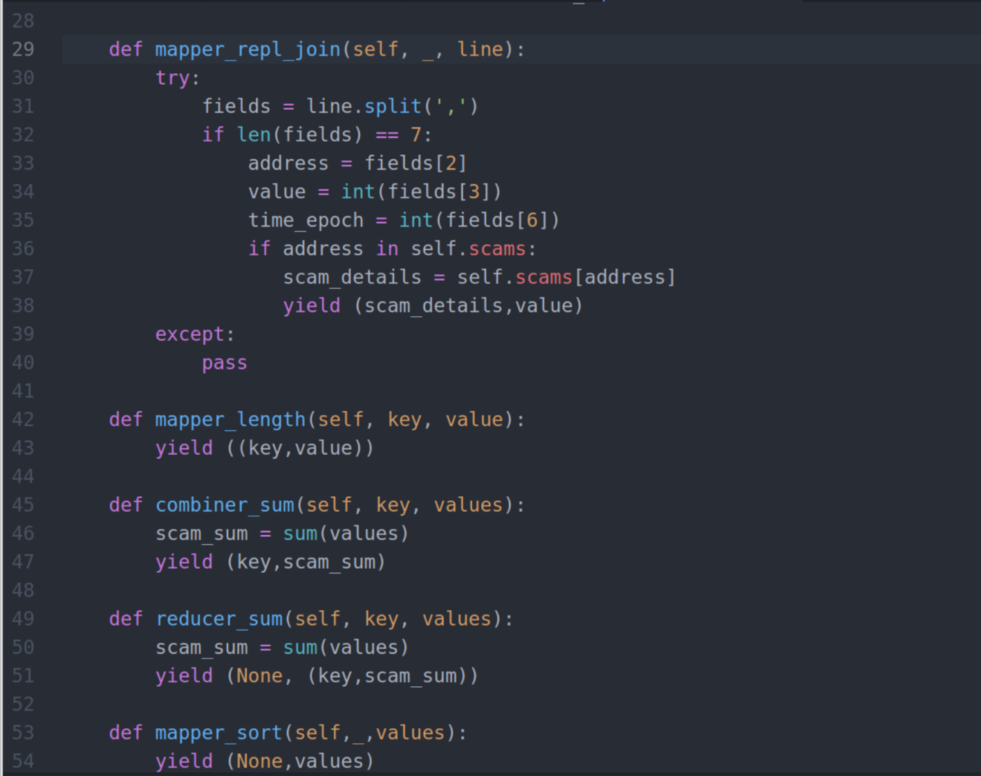

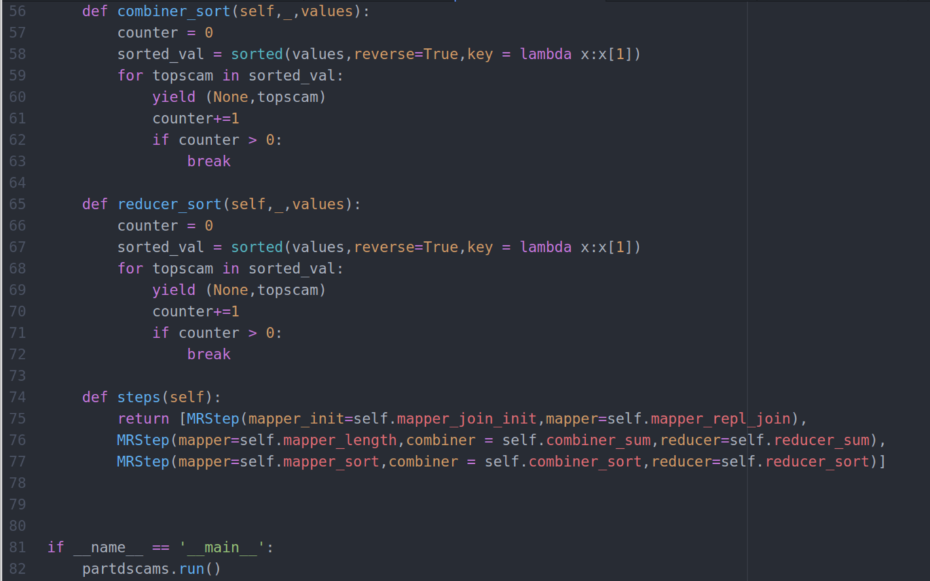

Figure 17: Mostlucrative.py

Code Explanation:

* Imports MRJob, Json, time to implement the functions and obtain top 10 most lucrative scams.
* In **mapper_join_init**, inputs from **scams.json** and transactions are collected and all attributes are extracted.
* **mapper_replication_join** is used to fetch the values with respect to date.
* **mapper_length** will take input value and date and returns address, value and year.
* **combiner_sum** will take input as address, value and year from mapper_length then returns address, year and aggregate values. combiner is used to reduce the execution time in aggregating values.
* **reducer_sum** will perform same function as combiner_sum and returns address, year and aggregate values.
* **mapper_sort** takes input from reducer_sum and then return the values with respect to date.
* **combiner_sort** is takes input from mapper_sort and then sorts the values in ascending order. Finally returns top 10 scams.
* Finally, in reducer_sort same combiner operation is done in the reducer, where key value pairs are sorted again from all the combiners to achieve the same result. To iterate between all records from the combiner, A for loop is used and the result is shown in the top 10 order. The for loop is terminated if the iteration count exceeds 11 in order to show only the top 10 values.
* **mapping_steps** defines each mapper, combiner and reducer process flow.

Command Line:

>>python Mostlucrative.py -r hadoop –file hdfs://andromeda.eecs.qmul.ac.uk/data/ethereum/scams.json –output-dir Mostlucrative_out –no-cat-output hdfs://andromeda.eecs.qmul.ac.uk/data/ethereum/transactionSmall

Job Id:

Step1 – <http://andromeda.student.eecs.qmul.ac.uk:8088/proxy/application_1607539937312_6094/>

Step2 – <http://andromeda.student.eecs.qmul.ac.uk:8088/proxy/application_1607539937312_6103/>

Step3 – <http://andromeda.student.eecs.qmul.ac.uk:8088/proxy/application_1607539937312_6112/>

Output:



Figure 18: Mostlucrative_out

Scam Analysis:

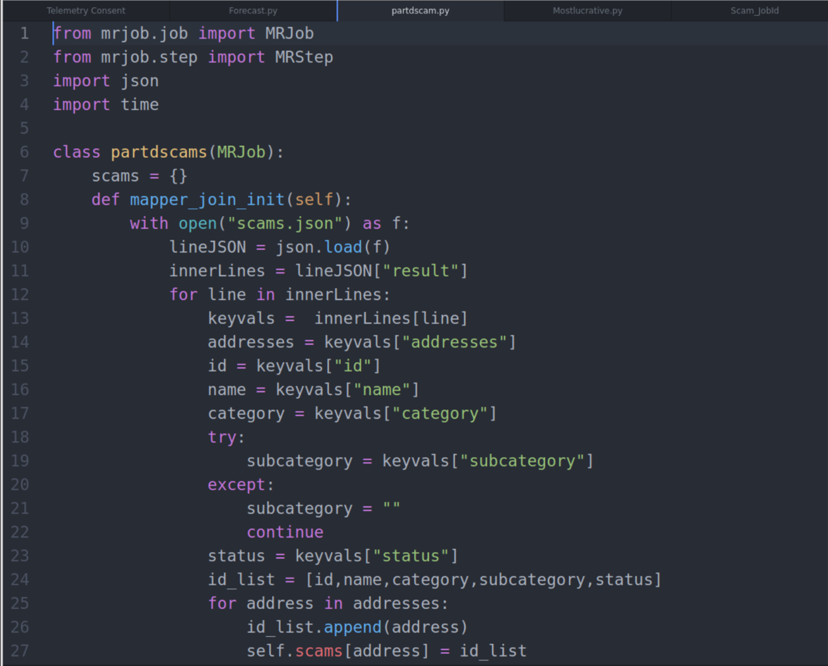

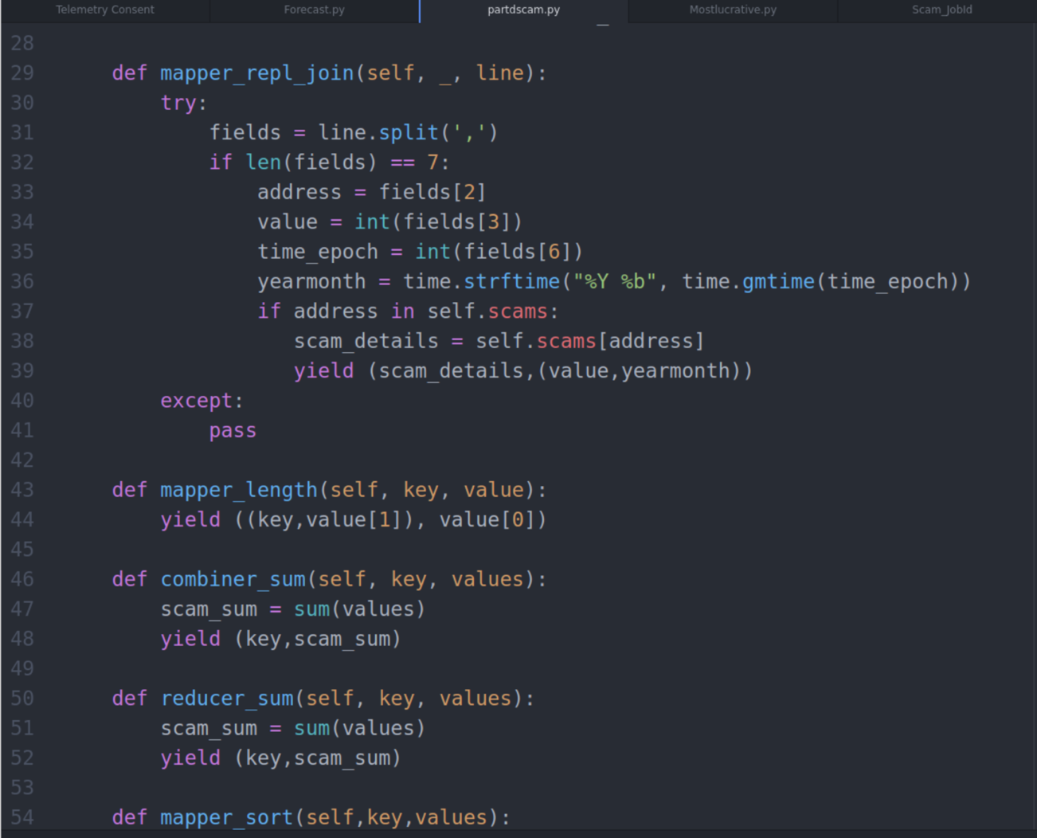

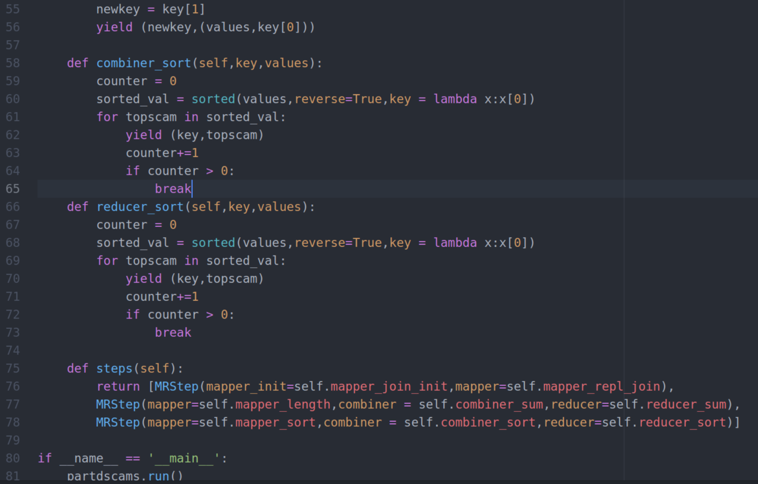

Figure 19: partdscam.py

Command Line:

>>python partdscam.py -r hadoop –file hdfs://andromeda.eecs.qmul.ac.uk/data/ethereum/scams.json –output-dir ScamAnalysis_out –no-cat-output hdfs://andromeda.eecs.qmul.ac.uk/data/ethereum/transactionSmall

Job Id:

Step1 – <http://andromeda.student.eecs.qmul.ac.uk:8088/proxy/application_1607539937312_5358/>

Step2 – <http://andromeda.student.eecs.qmul.ac.uk:8088/proxy/application_1607539937312_5368/>

Step3 – <http://andromeda.student.eecs.qmul.ac.uk:8088/proxy/application_1607539937312_5373/>

Output:

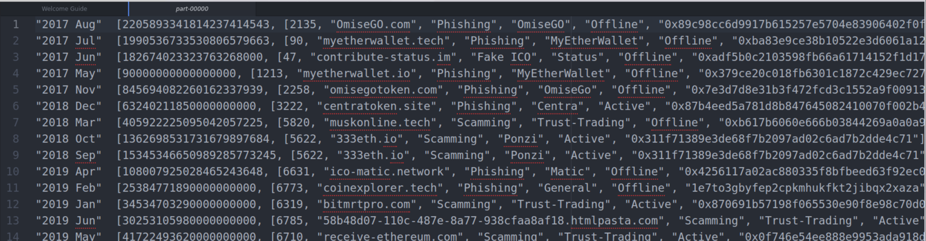

Figure 20: ScamAnalysis_out

Graph:

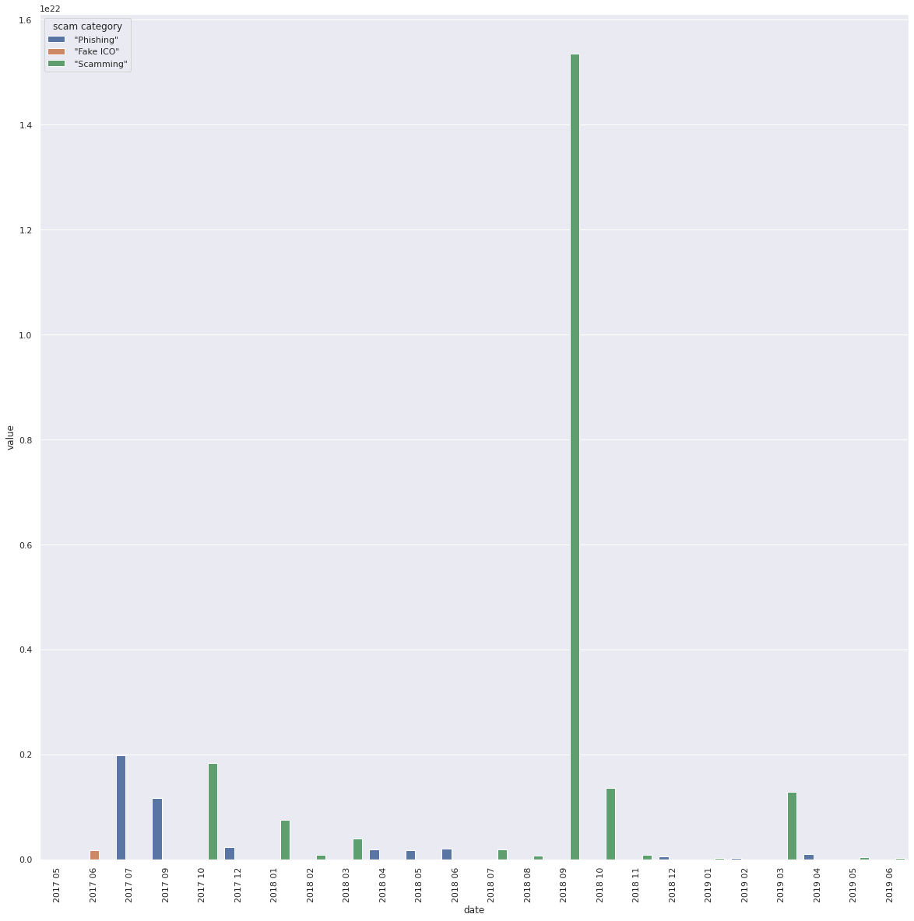

Graph 3: Changes throughout time

*MACHINE LEARNING*

*Price Forecasting: Find a dataset online for the price of ethereum from its inception till now. Utilising Spark mllib build a price forecasting model trained on this, the coursework dataset and any other useful information sources you can find. How accurate can you get your forecast within the coursework window to June 2019? How far past June 2019 does your forecast remain accurate? (20-25/50)*

Forecasting:

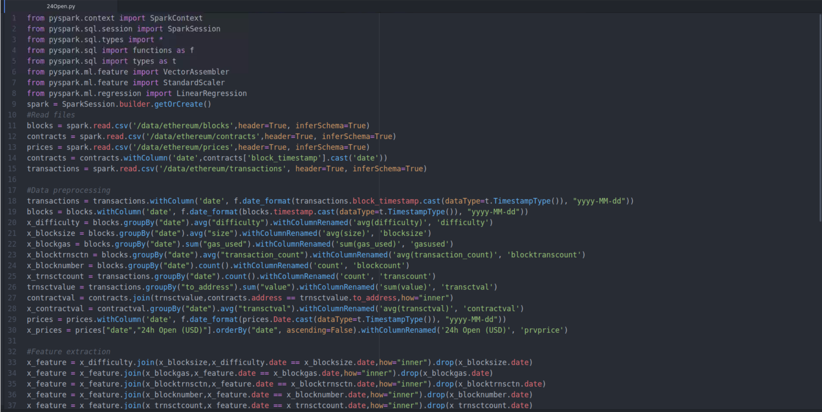

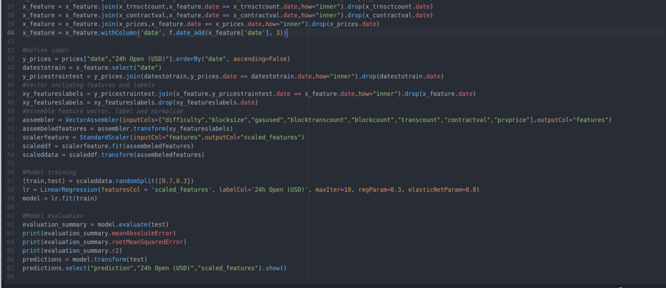

Figure 21: 24Open.py

Code Explanation:

* All the required libraries are imported. Here we are making use of **pyspark.sql** library.
* To begin with, all the dataset files transactions, blocks, contracts, prices are read into their respective variables.
* Data is pre-processed and brought into the required format by date.
* Feature extraction is done to consider previous 3 values of 24H Open (USD) field to predict the next value.
* The labels are defined further to normalise the feature vectors and to train the model.
* The data is split into 70/30 training and testing data.
* Linear Regression is used to train the model.
* Lastly, the model is evaluated, and it’s mean absolute error, root mean squared error and accuracy are calculated.

Job Execution:

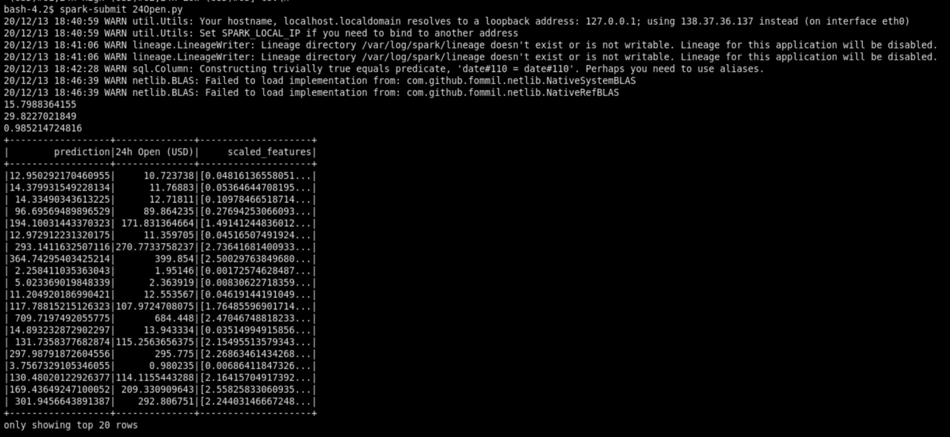

Figure 22: 24Open_out

* The mean absolute error is 15.79.
* The root mean squared error is 29.822
* The model accuracy is 0.98.

*MISCELLANEOUS ANALYSIS*

*Gas Guzzlers: For any transaction on Ethereum a user must supply gas. How has gas price changed over time? Have contracts become more complicated, requiring more gas, or less so? How does this correlate with your results seen within Part B. (10/50)*

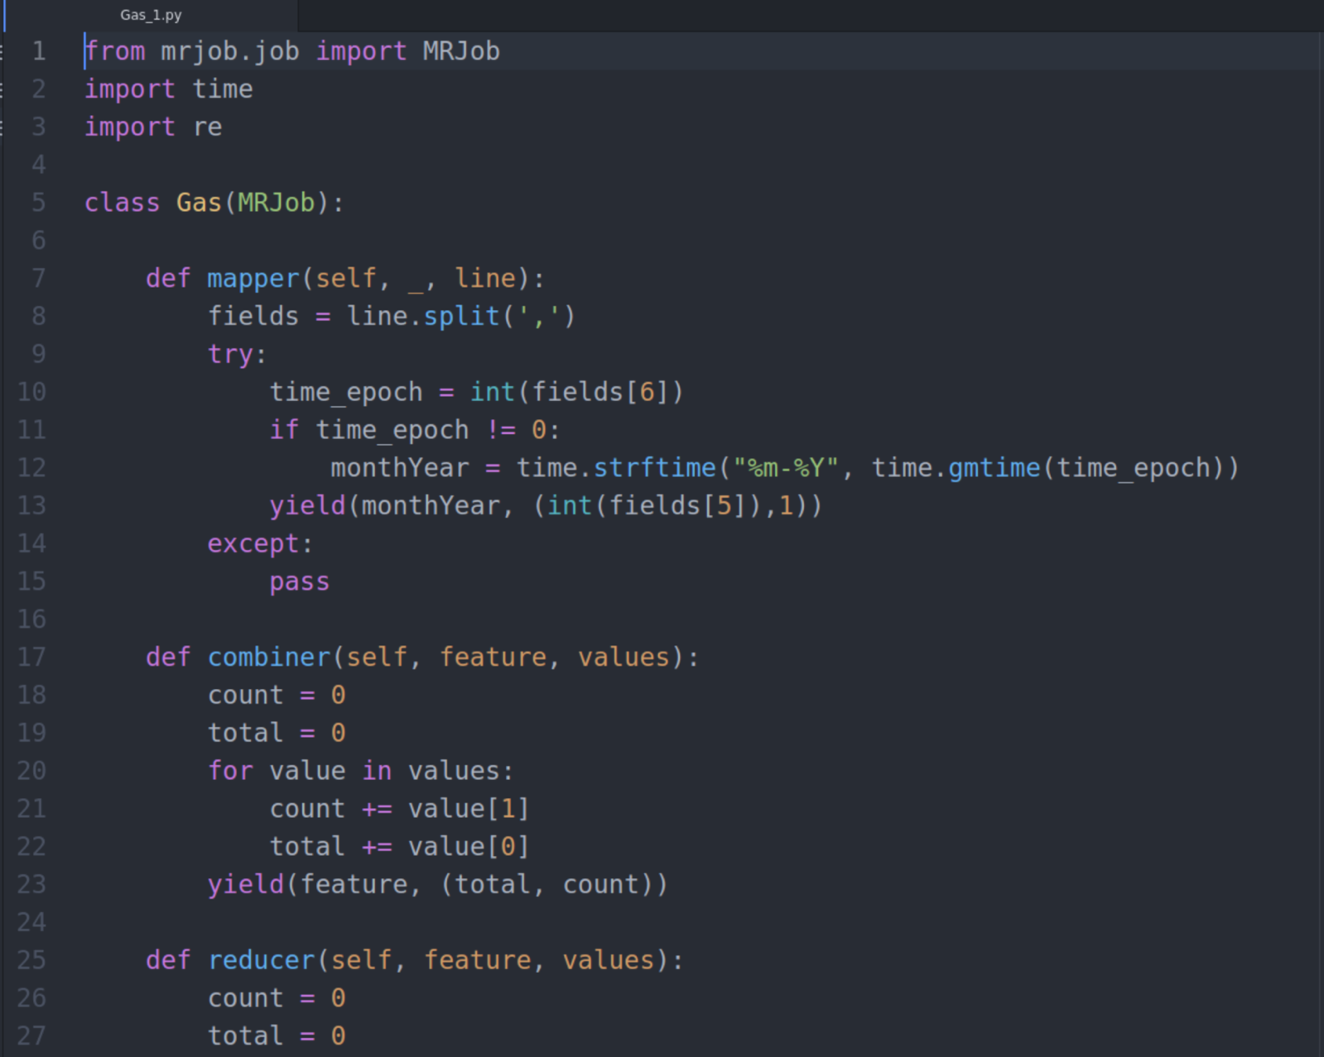

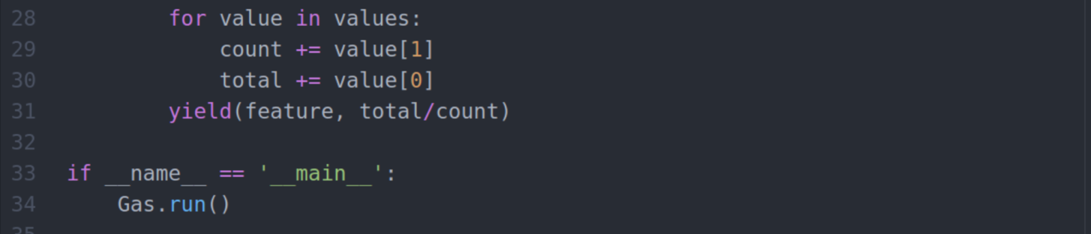

Figure 23: Gas_1.py

Code Explanation:

* 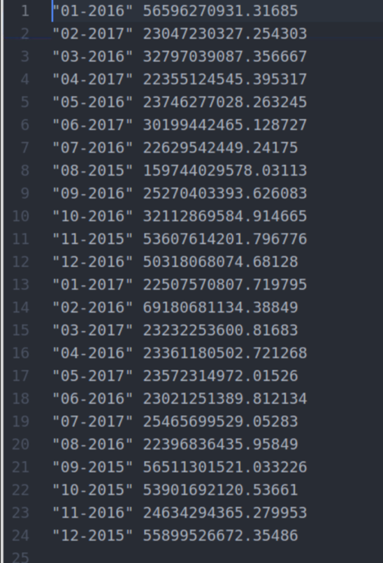To analyse the gas price change over years the gas price value in Wei and timestamp is used to perform the time series analysis. The average of gas price value per month gives us an insight of the gas price change over years.
* A map reduce job is used to perform this computation. In mapper **key** is **block_timestamp** field and **values** are **gas_price** and count 1 to count the number of occurrences which is used later in reducer to calculate the average. The Unix timestamp is converted to Gregorian format using **time** function.
* In combiner the **key** is the formatted timestamp and values are gas price and count. A for loop is used to calculate the sum of gas values and its number of occurrences per month.
* In reducer the total the same for loop logic is implemented and the yielded values are formatted timestamp and average of gas price per month. The average is calculated by dividing the sum of gas price with its total number of occurrences.
* Finally, the result is the average of gas price per month.

Figure 24: Gas_1out

Command Line:

>>python Gas_1.py -r hadoop –output-dir Gas_1_out –no-cat-output hdfs://andromeda.eecs.qmul.ac.uk/date/ethereum/transactions

Job Id:

<http://andromeda.student.eecs.qmul.ac.uk:8088/proxy/application_1607539937312_4356/>

Graph:

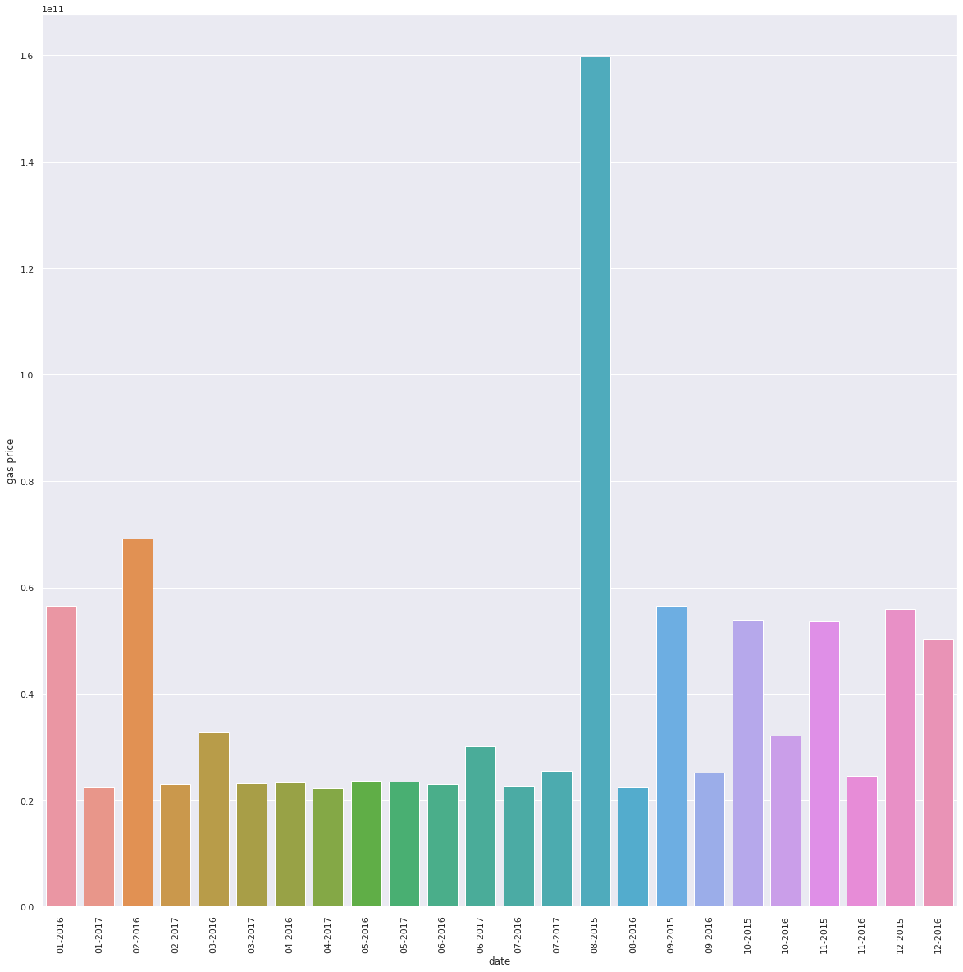

Graph 4: Gas price change over time

* To calculate average gas price per month.

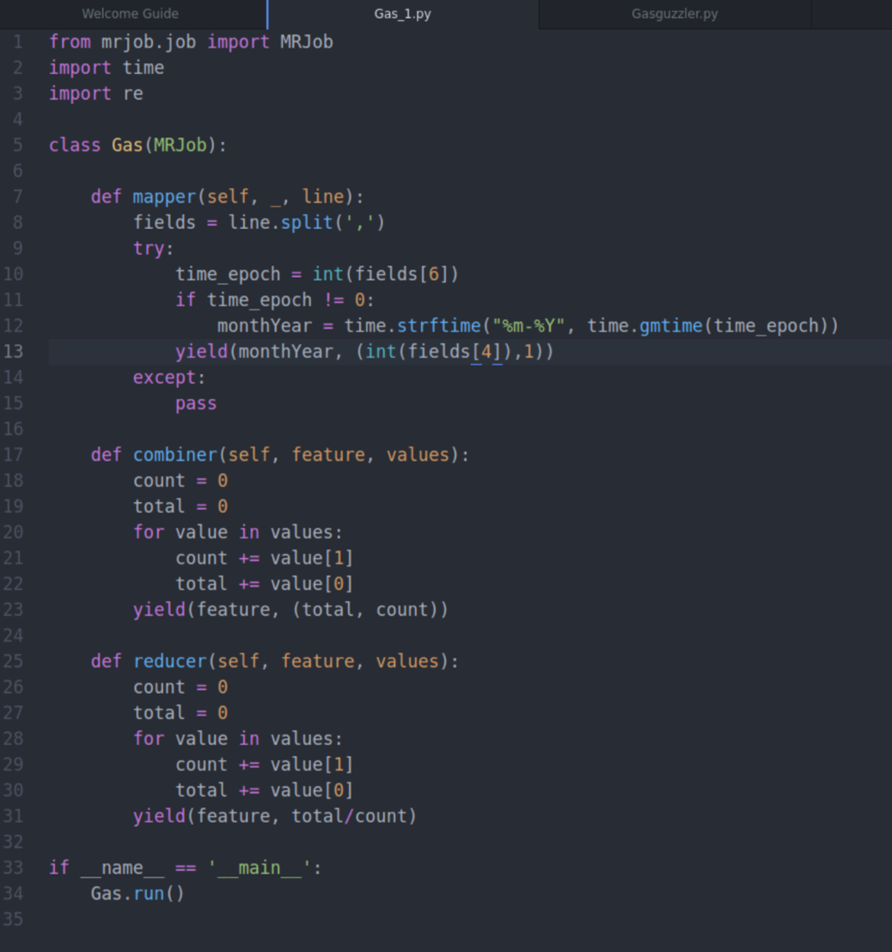

Figure 25: Gas_2.py

Code Explanation:

* To analyse the gas price change over years the gas price value in Wei and timestamp is used to perform the time series analysis. The average of gas price value per month gives us an insight of the gas price change over years.
* A map reduce job is used to perform this computation. In mapper **key** is **block_timestamp** field and **values** are **gas_price** and count 1 to count the number of occurrences which is used later in reducer to calculate the average. The Unix timestamp is converted to Gregorian format using **time** function.
* In combiner the **key** is the formatted timestamp and values are gas price and count. A for loop is used to calculate the sum of gas values and its number of occurrences per month.
* In reducer the total the same for loop logic is implemented and the yielded values are formatted timestamp and average of gas price per month. The average is calculated by dividing the sum of gas price with its total number of occurrences.
* Finally, the result is the average of gas price per month.

Figure 21: Gasguzzler_out

Command Line:

>>python Gas_1.py -r hadoop –output-dir Gas_2out –no-cat-output hdfs://andromeda.eecs.qmul.ac.uk/date/ethereum/transactions

Job Id:

<http://andromeda.student.eecs.qmul.ac.uk:8088/proxy/application_1607539937312_9061/>

Graph:

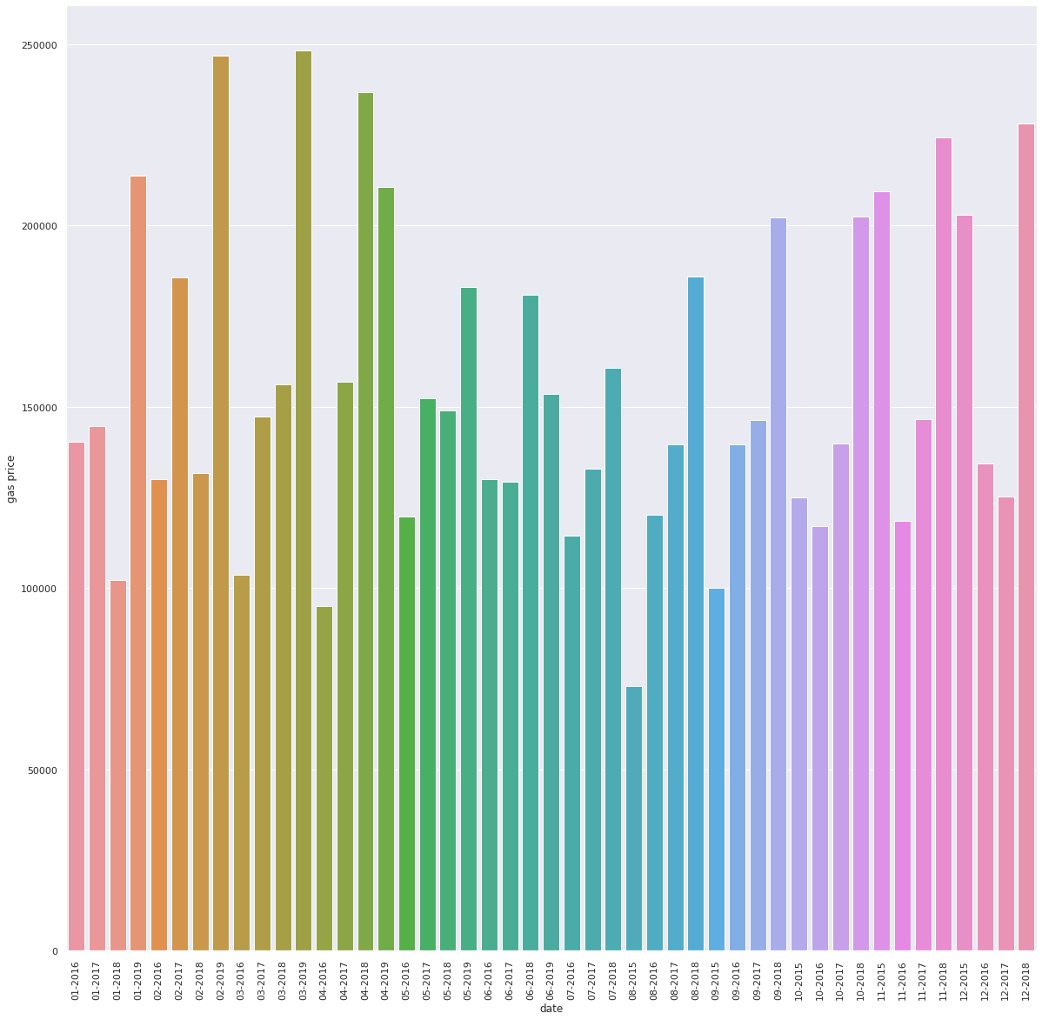

Graph 5: Average gas price per month

*Comparative Evaluation Reimplement Part B in Spark (if your original was MRJob, or vice versa). How does it run in comparison? Keep in mind that to get representative results you will have to run the job multiple times, and report median/average results. Can you explain the reason for these results? What framework seems more appropriate for this task? (10/50)*

* Single spark job to perform all 3 operations from PartB Map/Reduce jobs.
* First step is to calculate the aggregate counts for all transactions in the transactionSmall **dataset**. Second step is to filter out the smart contracts address from user address. Third step is to sort the address and filter out top 10 services.

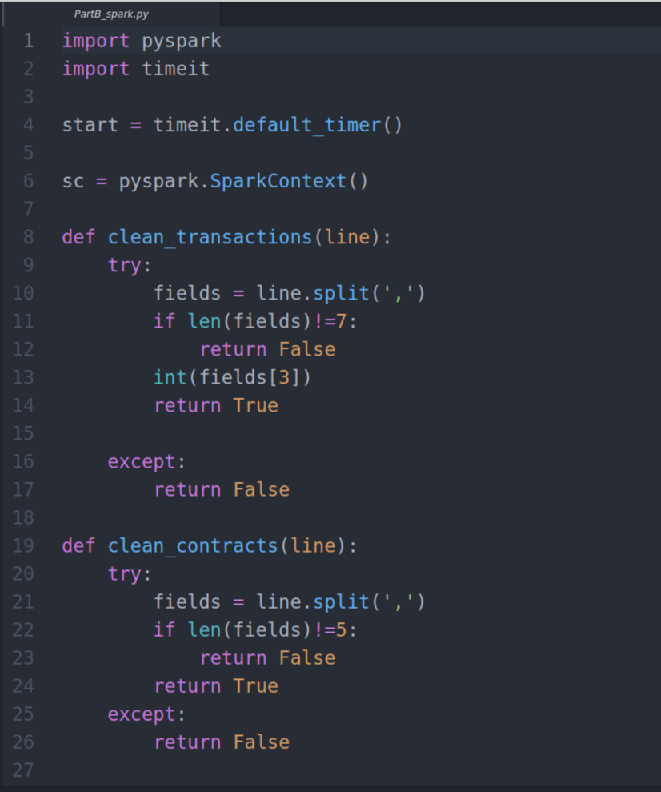

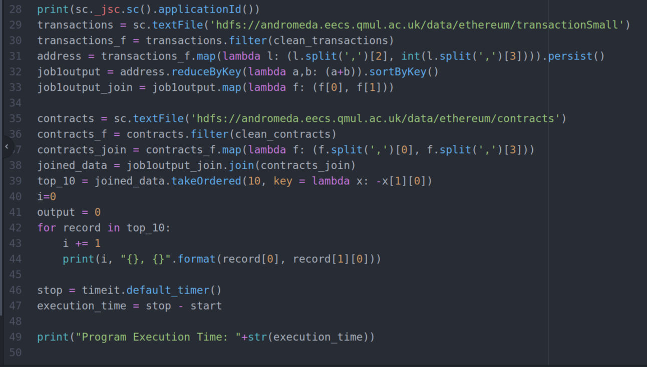

Figure 26: PartB_spark.py

Code Explanation:

* First line reads the transaction dataset using pyspark’s sparkcontext function. Second line filters any bad lines from transactions dataset using the user defined function clean_transactions.
* In third line using spark’s lambda function we map the key as **address** and value as **values** from transaction dataset. In fourth line we use spark’s **reduceByKey** function to calculate the aggregate of transaction **values.** This output is kept in memory.
* In fifth line we map the key as address and value as **aggregate values** from the output of previous operation. Spark’s in-memory processing is made use here. These values are stored in variable **job1output_join.**
* Sixth line reads the contract dataset. Seventh line filters out the bad lines from contracts dataset.
* Eighth line maps the key as **address** and value as **block_number** from contracts dataset using spark’s **lambda** function.
* Ninth line performs the join operation using spark’s **join** operation. Variable **joined_data** is the result of the joined dataset.
* Tenth line performs the sorting operation and filtering only 10 values using spark’s **takeOrdered** function. The symbol **‘-‘**in lambda function **x:-x[1][0]** sorts the values in descending order leaving top value at first.
* The final step is to format the values after sorting and print the top 10 services.

Job Id:

<http://andromeda.student.eecs.qmul.ac.uk:8088/proxy/application_1607539937312_5763/>

Output:

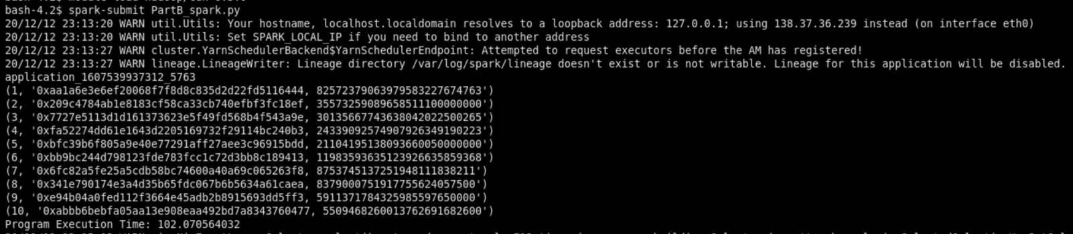

Figure 27: PartB_spark_out

Graph:

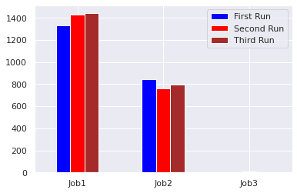

Graph 6: Time taken by Hadoop Jobs over multiple runs(s)

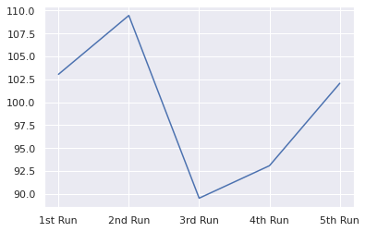

Graph 7: Time taken by Spark Job over multiple runs(s)

* Comparing the results of Hadoop and Spark jobs, spark jobs seems to perform faster for this task.
* This is due to Spark’s in-memory processing where the intermediate results can be stored in RDD and the next transformation or action can be applied to that RDD.
* Every time we execute Hadoop jobs the output data must be written and read to HDFS but in Spark we can directly read it from RDD.
* All three jobs of Part B can be implemented in a single Spark Job.
* Multiple maps and reduce steps in a single Hadoop job can be implemented for this task but the time taken to process the records by map reduce job will be more.
* The amount of shuffle and sort that takes place during join operation is large which reduces the job’s performance.
* Looking at the graphs the average time taken by Spark job is 99.44 seconds and Hadoop jobs is 2207.37 seconds. So it is clear that Spark jobs perform better than Hadoop Map/Reduce jobs.